2024 MGA Surplus Funding Proposal
PROJECT TITLE: STEM Outreach with XRP Robots
PROPOSAL SUBMITTED BY: IEEE REGION 3
PROJECT LEAD NAME: Allen Jones

PROJECT DESCRIPTION (Include how the requested funds would be expended, anticipated participation, and the desired outcome):
Following the pandemic, the Richmond Section noticed a major reduction in attention span among students at the area's annual STEM event. One of the activities that we traditionally offered was to teach youth how to solder together a basic circuit board. The board was a simple 555 timer circuit with the layout looking like a cat's face. The eyes on the cat would blink. Prior to the pandemic, we would usually have several dozen young students get their first introduction to electronics by successfully soldering together one of these boards. Following the pandemic, we only had one student who successfully soldered together a board. Most of the others soldered one resistor and then gave up. We decided to start looking into other options that could hopefully keep them engaged longer.
We began looking into robotics options. When the general public thinks of robotics and pre-university students, they usually think of FIRST Robotics, not IEEE. But FIRST Robotics focuses on High School and to a lesser extent on Middle School but with no real emphasis on university students. For many students who have not been exposed to engineering, waiting until high school is much too long to wait to spark their interest in the fields of study that are critical to becoming a successful engineer.
After exploring a number of robotic options, we learned about the XRP Robot. The XRP robot was developed by Worcester Polytechnic Institute and DEKA Research and Development under a grant from the US National Science Foundation (NSF). It was designed to be an inexpensive, yet highly adaptable platform that could be utilized in a variety of ways by students ranging from elementary school to university students. Partners in supporting the open-source XRP platform now include Sparkfun Electronics, DigiKey, the Raspberry Pi Foundation, STMicroelectronics, DAGU Robotics, the University of Idaho, MatterHackers, Manchester Community College Robotics, Allogy, Cornell University, and even FIRST Robotics.
All plans for the robot are open-source. You can choose to buy kits that contain all the components needed with the exception of 4 AA batteries (and charger if you decide to use rechargeable batteries) and a micro USB cable for $114.95 retail. Sparkfun, who packages up the collection of components, is willing to sell the kits to IEEE at the education price of $64.95. If you choose to buy the same kit minus the 3D-printed parts, the retail price is $94.95 and IEEE's price would be $54.95. The basic robot includes two servomotors, one servo, an ultrasonic range sensor connected via an I2C Qwiic Connector, a line following sensor connected via an I2C Qwiic Connector, and a six degrees of freedom (three degrees of linear acceleration, and three degrees of angular velocity) inertial measurement unit.
Students with no programming experience can program the robot using Blockly, a free graphical programming language. Just by following the included tutorials, they can create a robot that follows a line to a simulated package, picks up the package, and returns and delivers it to the user. More experienced users could choose to program the robot using the free WPILib programming environment, or choose to programming it using MicroPython, which is also free. Someone could even decide to experiment with the Inertial Measurement Unit's currently unused machine learning core and finite state machine.
These users could also expand the hardware capabilities of the robot. It can be readily expanded to use two more servomotors, one more servo, and two more I2C devices. (DigiKey, for example, carries thousands of different kinds of relatively low-cost I2C sensors and output devices.) Since the 3D-printed chassis and brackets are open source, the user is even free to redesign some or all of the mechanical pieces of the robot to better fit their application.
Free training resources are provided, but the partnership promoting this platform is looking for more groups to add to their initial content. This is where IEEE members can help.
We propose that IEEE use these robots in STEM Outreach events, including donating robots to schools, public libraries, etc. MGA and participating Regions would share in the costs of providing the robots. Sections that received funding for the robots would also be required to contribute at least one new lesson plan that made use of the robots to the TRYEngineering website.
Printing the plastic parts ourselves would allow us to include the IEEE logo and a QR code on the side of the chassis. A QR code that encluded a serial number such as (the not yet active) URL https://ieee.org/xrp/?sn=123456, would give us an indication of which robots were being spotted the most frequently out in public. Using IEEE's standard mechanism for handling redirects, it could also take the viewer to a web page that included a variety of information regarding IEEE's work in the field of robotics. For example, it could have links to pages for the tryengineering.org information on robotics, the IEEE Robotics and Automation Society, and university student robotics competitions such as the Hardware Competition at SoutheastCon.
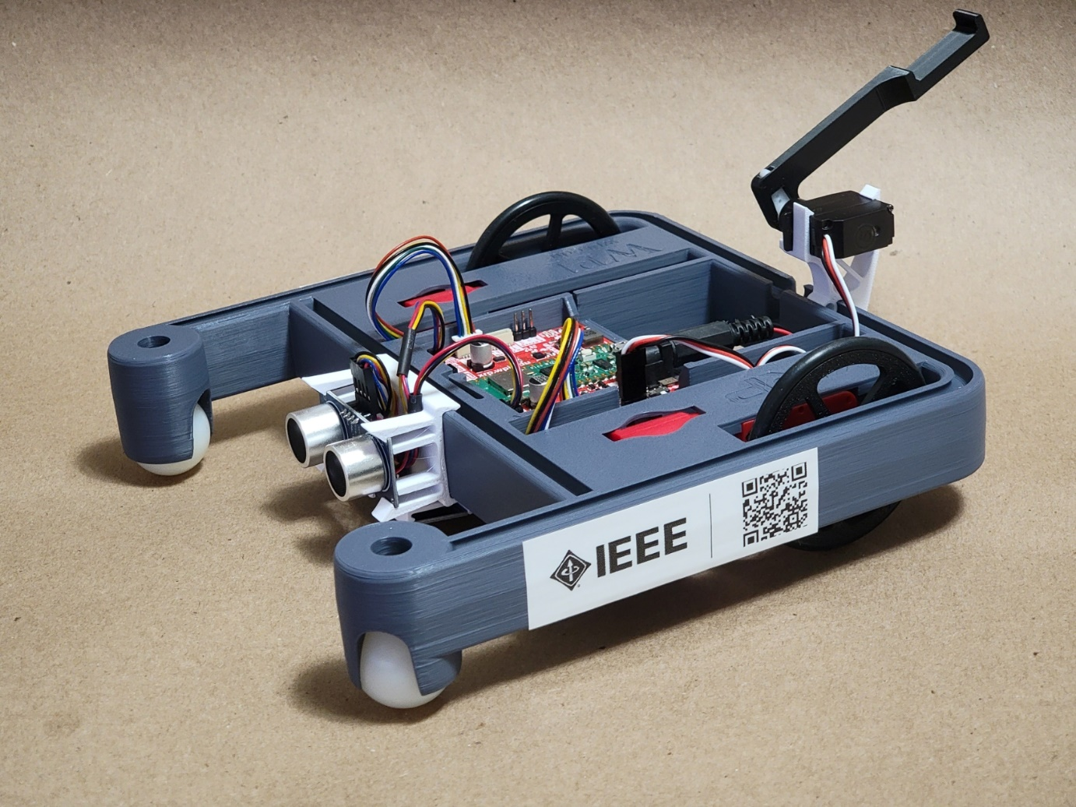
Directing the public to the tryengineering.org website when they were looking for K-12 robotics information, would also potentially increase donations to the TRYEngineering organization since they commonly solicit donations from people who sign up from their newsletters. The tracking afforded to us by the previously mentioned sample https://ieee.org/xrp/?sn=123456 URL would easily allow us to see not only that the user reached this page by scanning a robot, but also which robot they scanned. If the increased exposure was large enough, TRYEngineering could decide to cover the cost of providing ongoing funding for more robots. It could also decide to offer robots to IEEE members at a price that was somewhere between the retail price of $114.95 and the educational price of $64.95, thus saving IEEE members money while also generating a source of revenue for TRYEngineering.
Does the project involve more than one Region (if yes, please name Regions):
The project currently only involves Region 3 but can easily be expanded to include other Regions. Sparkfun ships to most countries that are not on a US export control list.

How the project shall address member engagement, member retention, member recruitment?
This addresses member engagement, retention, and recruitment in several ways:
- Many children who already participate in STEM events have parents or relatives who are already engineers, but may not be IEEE members. Letting these parents or relatives see that IEEE is interested in supporting their children's learning may make them see IEEE in a new light and encourage them to join.
- Providing free opportunities for some students to learn about robotics who would otherwise never have the opportunity to do so can be life-changing for students in underrepresented communities.
- Having Sections actively developing learning materials gets the Sections more engaged.
- Having these materials freely distributed to the public increases their awareness of IEEE's important work in these fields.
- Letting students become familiar with the IEEE name early in their STEM learning makes them more likely to think of IEEE as they become university students and professionals.

Description of the short-term and long-term impact of the project:
Increased exposure of children and their parents to robotics and IEEE's involvement in the field.
Increased association in the public's eye between robotics and IEEE's critical involvement. Much of the general public does not realize how much electronics and computers are critical to robotics. The main thing that they see is the mechanical aspects. But a robot without electronics or software would not be much more advanced than an early 19th century cuckoo clock.
Project Budget (USD) (Split % of the budget between Region & MGA):
Income
IEEE Region 3 (Approved by ExCom) USD $5000
IEEE MGA Funding (if approved) USD $10,000
Expenses (assuming 150 kits)
XRP Robot DIY Kits - $55/kit USD $11,000
3D Printed Parts - $10/kit USD $2,000
Rechargeable batteries, battery charger, USD $5,000
micro-USB Cable - $25/kit
Miscellaneous expenses - $10/kit USD $2,000

Software requirements, if any:
IEEE hosted WordPress site using standard IEEE tools for volunteer administered websites.
Estimated start/completion dates:
Start Date - 7/1/2024
End Date – 12/15/2024

Additional sections/comments

